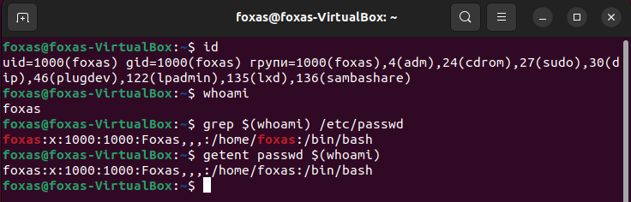

Id – Print the identifiers of the current user and his groups.

Whoami – Print only the name of the current user: